Lupron Depot Workflow

Lupron is a medication that providers can sometimes order for patients. Different strengths are used to treat different conditions such as symptoms of endometriosis or fibroids prior to surgery. In most cases, this medication will need a prior authorization.
- Provider places order for medication and sends to patients preferred pharmacy.
Note: provider may need to search this using Facility List or Database to find the appropriate House prescription to send.
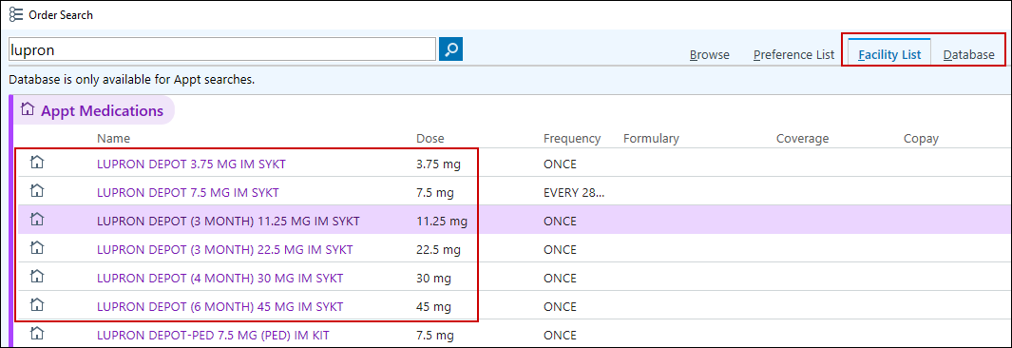
- Provider sends a staff message to POD Pool to let them know the medication was ordered.
- Once the pharmacy receives the prescription, they will send a request for needed prior authorization (PA) if patients insurance requests it.
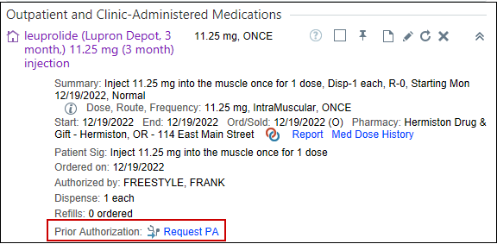
- Click the link Prior Authorization Tip Sheet and follow PA the workflow.
- Once the PA is approved, add to your documentation the approval number and the length of the approval (3mo, 6mo, 1yr, etc) along with the other PA required documentation.
You will need to keep the phone note open until the next few steps are completed and the patient has an appointment scheduled.
- Contact the patient to inform them of the approval and next steps.
- Instruct patient to call their pharmacy to make sure they can order the Lupron or if it will need to be ordered through a specialty pharmacy.
*Note: You may choose to have an MA/LPN call the pharmacy on the patient’s behalf.
  - If the pharmacy cannot order and they need a specialty pharmacy, then we need to call to set up delivery.
  - You can ask the patient’s pharmacy for a list of specialty pharmacies they work with.
- Once medication is ready, patient should be instructed to pick up Lupron, unless the medication has been delivered to a WHA location, then call the office to schedule their injection appointment.
*Note: Appointment should only be scheduled once the patient has verified they have the medication in hand.
- Sign the encounter once the appointment is scheduled.

Documenting Medication Administration of Depot Lupron.

This may be scheduled as an Injection visit on the Lab schedule with a trained Lab Assistant or as a Nurse visit with an MA/LPN.
Scenario: Patient has now arrived and you call them back to the exam room.
First, double click the patient’s visit to open for documentation.

Rooming Activity: 
Patient states they are here for their Depot Lupron Injection and have the medication in hand.


- Type: Injection, comment: Depot Lupron


You will need to take current vitals for today’s visit.
- BP: add Site, Position, and Cuff size, Pulse, Temp and Source, Weight/Height: add Comment: Prior weight/height when applicable, SpO2%

Update OB/GYN Status
- Menstrual Status, LMP, and Breastfeeding
- Click Mark as Reviewed

For Meaningful Use, verify patient’s Tobacco Status.
- Click Mark as Reviewed


Verify with patient that their Allergy list is correct.
- Click Mark as Reviewed


Verify patient’s pharmacy, and what medications they are currently taking.
- Update Med List Status: Best possible list obtained.
- Click Mark as Reviewed.

You will need to add an order for the Depot Lupron injection in order to document the injection on the Medication Administration Record (MAR).

Orders Activity: 
Now, place an order for Depot Lupron.
- Click the Preference List  icon. Located in the bottom visit taskbar.
- Order Search: type; Depot Lupron.
- Double click on the medication administration order that matches the medication brought in by the patient or was delivered to the clinic to add it your list.
- Click Accept.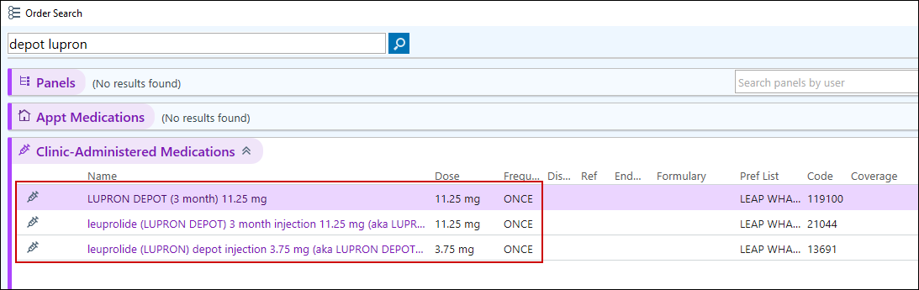
- Click on Unsigned Order.
- Click DX Associate.
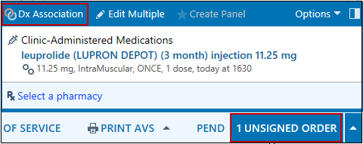
- Choose a diagnosis from the Problems List and associate.
- Click Accept.
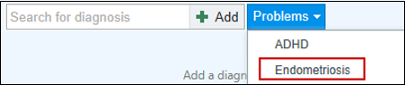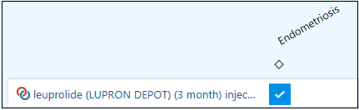
- Sign Orders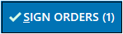.
- Click Dose/Therapy Appropriate.
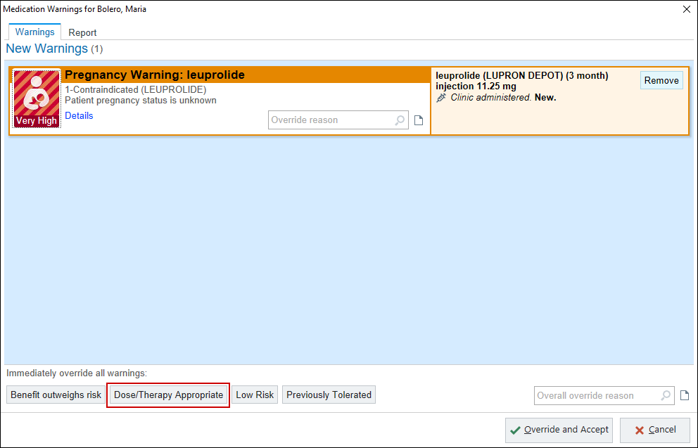
- Add Ordering Information.
- Click Accept.
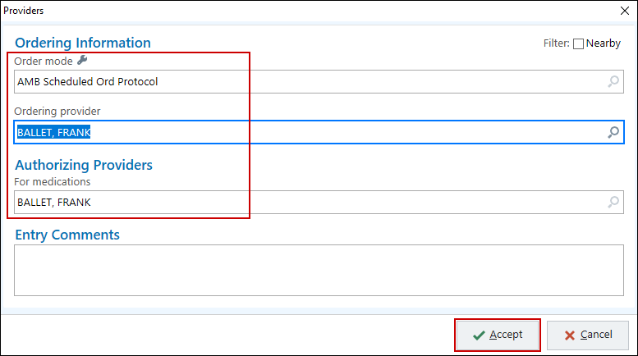
- Have patient read and sign consent form prior to injection.

MAR activity: 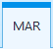
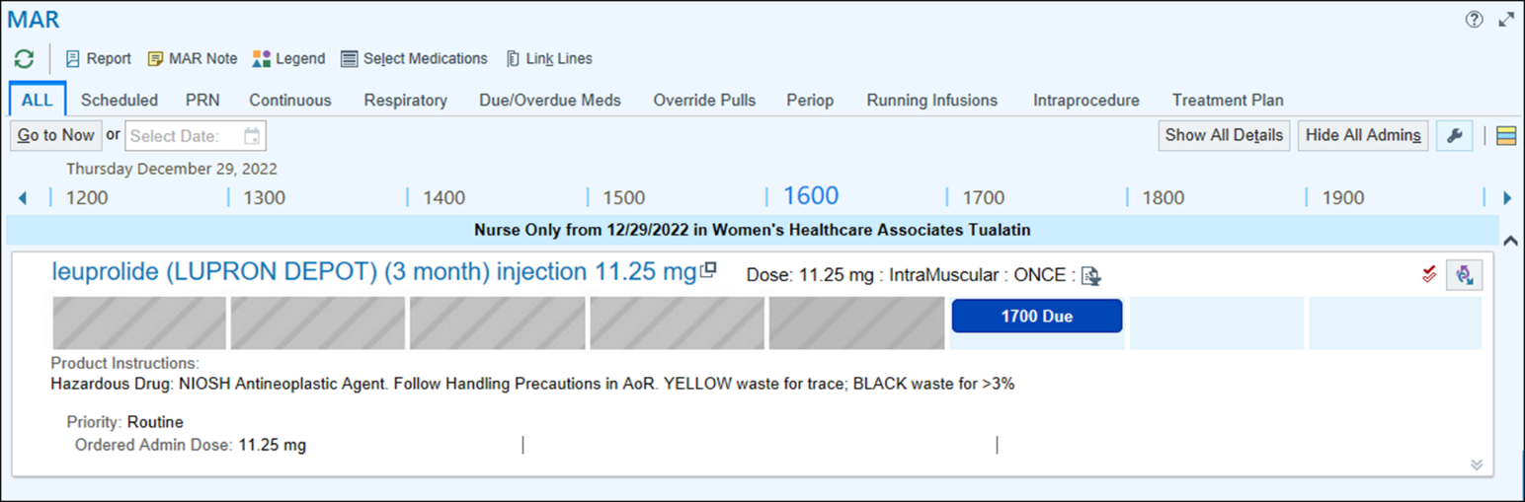

- Click the Due box to begin documentation
- Document the Site: Vento gluteal
- Patient Supplied: make sure this box is checked.
- Document the NDC: use the selection tool to search if needed.
- Document the Lot #:
- Add Expiation Date.
- Billing Provider: if not seen.
- Click Accept.
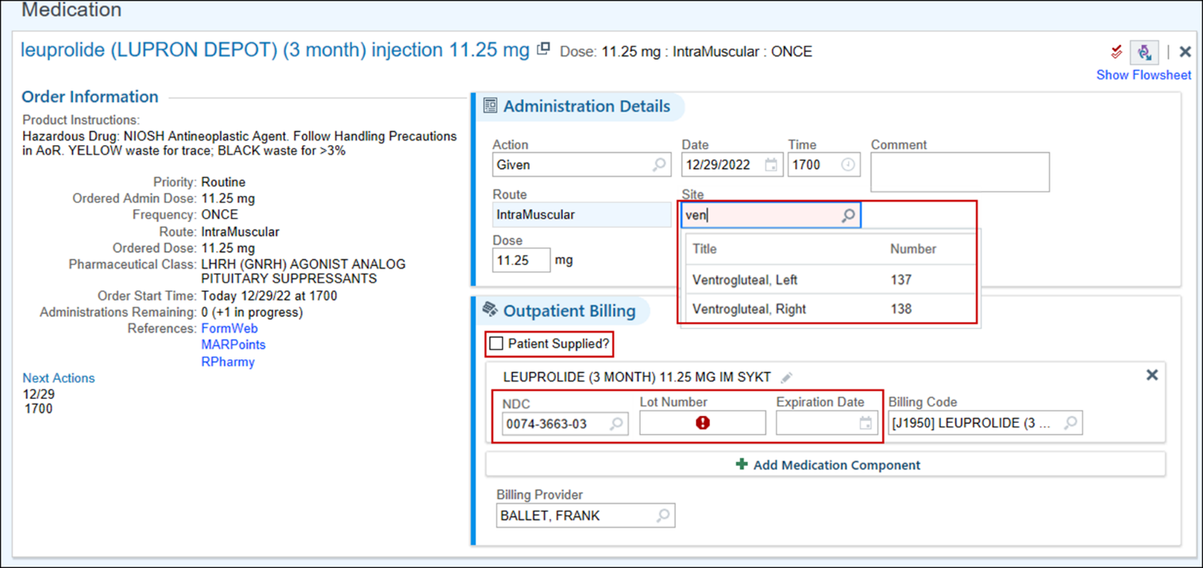
This medication requires a Dual Signoff.
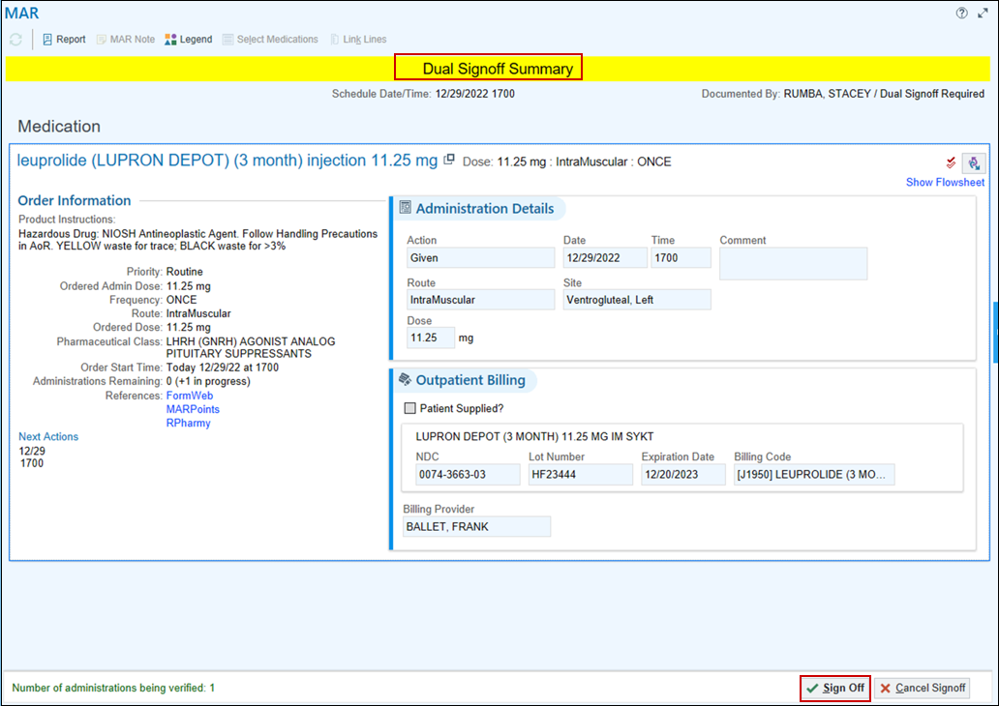
- Click Sign Off.
A User Authentication window opens.
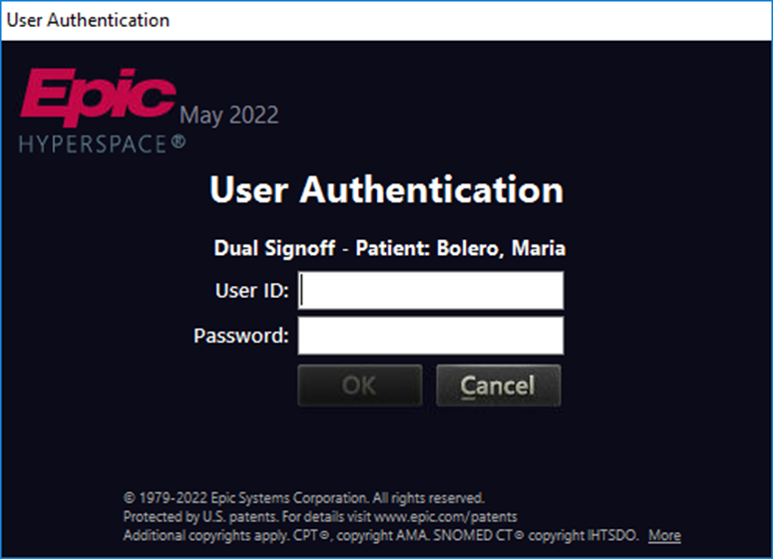
- The Dual signer should be another clinical team member (this can be a lab assistant, MA, RN or provider).
- Patient should be observed for at least 15 minutes either in the Lobby or an Exam room.
Progress Note Activity: 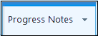
You can begin documenting the injection into the note.
- In a blank spot in the Progress Note type the following information: Injection Site, Location given, who gave it, observed for ***, Lot, NDC, and Expiration date. Add you signature at bottom.

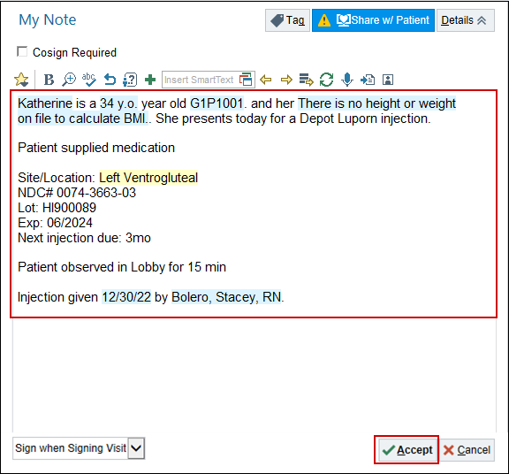

This Visit Activity: 

Follow Up 

- Depends on Lupron treatment type
  - Fibroids: one injection prior to surgery
  - Endo: every 3 months
  - PA usually approved for 6 months or a year.
- Staff message to POD Pool that is postponed/delayed to be sent on specific date to contact patient for next injection. Include: Medication, PA information (3mo, 6mo, 1yr), provider, Key Code, etc.
You will need to document the Level of Service for today’s visit.
- In the bottom task bar find the LOS field.
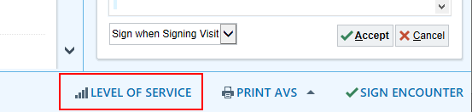
- Click the PR NURSE VISIT NO CHARGE button to select that level of service.
- Auth prov field: type in ordering provider.
- Press Enter, or try “=” to pull in the same provider.
- Click the Sign Encounter button 

The Schedule will show her appointment as ‘Signed’

Depot Lupron Follow-up Injection(s) from postponed staff message.

Go to InBasket 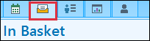
- Click on the Staff Message task folder.
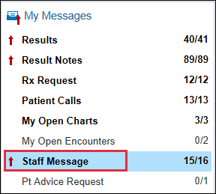
Locate your Depot Lupron message.
- Take the Baton.
- Review the message.
- Ensure PA is still active.
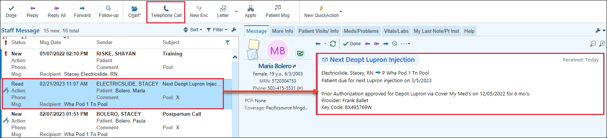
- Click Telephone Call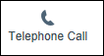.
- Add Provider name.
- Click View Calls.
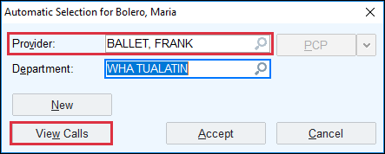
In Basket Action window opens
- Click Yes to add the staff message to your phone encounter.
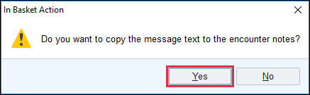
- Document call to patient.
  - Called specialty pharmacy to inform of next inject due and need to schedule next delivery. Patient informed she is due for her next Depot Lupron injection. Medication reordered through… awaiting… prior to scheduling.
- Route back to POD pool if not complete.
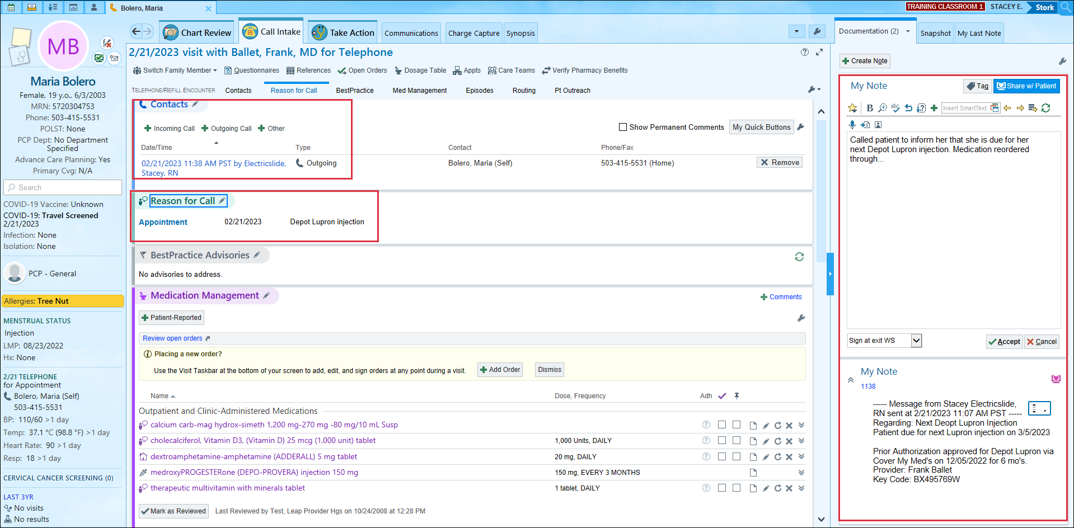
- Only Sign encounter when medication has been picked up by patient or delivered to clinic and Lab appointment has been scheduled.

